ImportData using Transform Maps (Spreadsheet)

Phase-5 -- Project Development Phase

Date | 28/9/2026
Team Id | SWT ID -2026-5783
Project Name | Import Data using Transform Maps (Spreadsheet)

Team Members:
Name | Roll.no
K.Tharanika | U24CSE1450
E.Vijitha | U24CSE1455
K.Kiruthiga | U24CSE1420
N. Suhaila begum | U24CSE1447
K.Thilagapathi | U24CSE1452

ProjectDevelopmentOverview
ThisphaseconvertsplannedconceptsintoconcreteServiceNowconfigurationandtestingsteps.Activities focusondevelopmentartifactsandtheirverificationratherthanplanningdecisions.

  - Developemployee dataimportsolutionusingImportSet/TransformMap.
  - Createtargettable:EmployeeTest(u_employee_test).
  - Createstagingtable:EmployeeImport(u_employee_import).
  - Prepareandloadthespreadsheet(SampleSpreadsheet.xlsx,Sheet 1,headerrow1).
  - ConfigureTransformMapandsource-to-targetmappings.
  - EnableCoalesceonEmployeeIDtopreventduplicates.
  - Executetransformandvalidateinserted/updated records.
  - Developreportsand assembleEmployeeAnalyticsDashboards.
  - DeveloptheEmployeeTesttablewiththerequiredemployeefields.
  - DeveloptheEmployeeImporttableasthestagingareaforincomingspreadsheetrecords.
  - PrepareemployeedatawithEmployeeID,EmployeeName,Email,Department,andLocation.
  - LoadspreadsheetrowsintotheImportSetstagingtable.
  - Verifythattheimportedstagingrecordsareavailable beforetransformation.
  - Configuresource-to-targetmappingsbetweentheImportSetandEmployeeTesttables.
  - ReviewtheTransformMap configuration beforeexecutingthetransformation.
  - TestnewandexistingEmployeeIDstoverifyinsertandupdatebehavior.
  - Reviewtransformationresultstoidentifyinserted,updated,andignoredrecords.
  - Verifythefinalemployeedatathroughreports andthecentralized dashboard.

Development Environment and Project Setup
SetupacontrolledServiceNowdevelopmentenvironmentandverifyprerequisitesbefore configuration.

- ObtainaServiceNowdevelopment/learninginstance.
- Ensureuseraccount withrolestocreate tables,importsets,andreports(adminor equivalent).
- OpentheDataImport/LoadDatamoduleintheinstance.
- PrepareSampleSpreadsheet.xlsx(Sheet 1,headerrow1)onthe localworkstation.
- Create placeholdersfor u_employee_importand u_employee_test or confirm they do not conflict with existing objects.
- Confirm availabilityofImportSetframeworkandTransformMapfunctionality.
- VerifythattheServiceNowinstanceisaccessiblebeforebeginningdevelopment.
- Confirmthattherequiredemployeedataimportfunctionalityisavailable.
- Preparethespreadsheetfileforthedevelopment import.
- VerifythatSheet1containstheemployeedata.
- Confirmthat row1containsthespreadsheetcolumnheaders.
- Verify the five required employee fields: Employee ID, Employee Name, Email, Department, and Location.
- CheckthattheplannedEmployeeImportstagingtablecanbeusedforincomingdata.
- CheckthattheplannedEmployeeTesttablecanbeusedasthetargetfortransformedrecords.
- Confirm that the development environment is ready for Transform Map configuration and data transformation.
- Verifytheenvironmentbeforeproceedingtotablecreation,dataimport,transformation,andtesting.

EmployeeTestTableDevelopment
Develop the target table that will store transformedemployee records.Keep schema minimal and aligned with sourcefieldsto simplifymappingandvalidation.

  - Label: EmployeeTest
  - Tablename:u_employee_test
  - Fieldstocreate:
    - EmployeeID —String
    - EmployeeName—String
    - Email—String
    - Department—String
    - Location—String
  - Setappropriatefieldlengthsandrequiredflagswherenecessary(e.g.,EmployeeIDrequired).
  - Documenttableandfielddefinitionsforprojectrecords.


CreateEmployee ID
CreateEmployeeName
CreateEmail
VerifyTargetTable

EmployeeImportStagingTable Development
CreatetheImportSetstagingtabletoreceiverawspreadsheetrows.UsethistableastheTransformMap source to ensure controlled transformation.

  - Label: Employee Import
  - Tablename:u_employee_import
  - Definesourcefieldstomatchspreadsheetheaders:EmployeeID,EmployeeName,Email,Department, Location.
  - Usethestagingtableonlyforrawdata;donotaddbusinesslogicorderivedfieldshere.
  - VerifythetableisavailableintheLoadDatawizardbeforeuploadingthe spreadsheet.

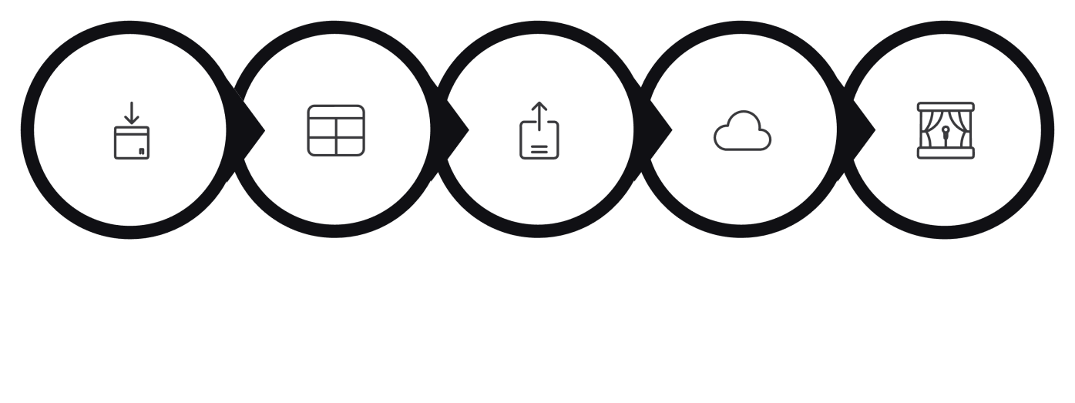
CreateImport
Prepare Fields
UploadSheet
LoadData
Import Staging

  - CreatetheEmployeeImporttableasthestagingareaforincomingemployeespreadsheetdata.
  - Configurethetablenameasu_employee_import.
  - Preparethefivesource fieldsrequiredfortheemployeeimport.
  - MaintainEmployeeIDaspartofthesourcedataforrecordidentification.
  - IncludeEmployeeNameasasourcefieldforemployeeinformation.
  - IncludeEmailasasourcefieldforemployeecontactinformation.
  - IncludeDepartmentasasourcefieldfordepartment-basedreporting.
  - IncludeLocationasasourcefieldforlocation-basedreporting.
  - Verifythatthestagingtablecanreceivethespreadsheetrecordsbeforetransformation.
  - ConfirmthattheEmployeeImporttableisreadytoactasthesourcetablefortheSample
SpreadsheetImportTransformMap.

SpreadsheetDataDevelopment
Prepare a controlled samplespreadsheetfor developmentand test imports. Includeexamplesto exercise insert, update, and ignored outcomes.

  - Filename:SampleSpreadsheet.xlsx
  - Sheet:Sheet1;Headerrow:Row1
  - Columnsrequired:EmployeeID,EmployeeName,Email,Department,Location
  - Createsamplerowsincluding:
    - TwonewEmployeeIDs(forinserttesting).
    - TwoexistingEmployeeIDswithmodifiedfields(forupdatetesting).
    - Rowsthatwillbere-importedtoverifyidempotency.
  - Saveandretain thespreadsheetforrepeatedimport tests.


PrepareEmployee
Data
ReadyforImport
Spreadsheet.
Sample
xlsx

  - reparethespreadsheetusingaconsistentcolumnstructure.
  - KeepEmployeeIDavailableforeverytestrecord.
  - UseuniqueEmployeeIDsforthenew-recordtestcases.
  - UseexistingEmployeeIDsfortheupdatetestcases.
  - Changeemployeeinformationsuchas EmployeeNameorEmailforupdatetesting.
  - KeepDepartmentvaluesavailablefordepartment-basedreporttesting.
  - UsethepreparedspreadsheetasthecommoninputforImport,Transform,Insert,Update,and Ignorevalidation.

ImportSetDevelopment
PerformtheImportSetsteps toloadspreadsheetrecordsintothestagingtablepriortotransformation.

  - OpenLoadData(Data>LoadData).
  - SelectSampleSpreadsheet.xlsx.
  - ChooseSheet1andspecify Row1asheader row.
  - MapthespreadsheettotheImportSettableu_employee_import(createanewimportsetif required).
  - Executethe loadandconfirmthe ImportSetshowstheexpectednumberofrows.
  - ResolveanyparsingerrorsbeforeproceedingtoTransformMap configuration.

SelectFile
ChooseSheet
SetHeader Row
Load&Verify

  - VerifythatSampleSpreadsheet.xlsxcontainstherequiredemployeecolumnsbeforeloading.
  - OpentheLoadDatafunctionalitytobeginthe spreadsheetimport.
  - Select thepreparedspreadsheetas the importsource.
  - SelectSheet1fromthespreadsheet.
  - SetRow1astheheaderrow.
  - Confirmthatthespreadsheetcolumnsarerecognizedcorrectlyduringloading.
  - Use Employee Import(u_employee_import)asthestagingtable.
  - Verifythat theuploadedspreadsheetrowsareavailableinthestaging table.
  - ConfirmthattheImportSetcompletessuccessfullybeforetransformation.
  - ReviewtheloadeddatabeforerunningtheSampleSpreadsheetImportTransformMap.

TransformMapDevelopment
Configurethe TransformMap to movedata fromthe staging tableto the EmployeeTest table.UseAuto MapandMappingAssistforaccuracy,thensaveandpreparefortransformationexecution.

  - TransformMapName:SampleSpreadsheetImport
  - SourceTable:u_employee_import
  - TargetTable:u_employee_test
  - Configuremappings:

- EmployeeID→EmployeeID
- EmployeeName→EmployeeName
- Email→Email
- Department→Department
- Location→Location

  - UseAutoMapMatchingFieldsforexactheadermatches;useMappingAssistformanualmapping corrections.
  - ReviewandsavetheTransformMap;documentthemappingdefinitions.
  - CreatetheTransformMapafterthe EmployeeImportstagingtableisavailable.
  - SetSampleSpreadsheetImportas theTransformMapname.
  - Select u_employee_importas thesourcetable.
  - Selectu_employee_testasthetargettable.
  - Verifythat thesourcefieldsareavailableformapping.
  - VerifythatthecorrespondingtargetfieldsareavailableinEmployeeTest.
  - MapEmployeeIDfromthesourcefieldtothetargetEmployeeIDfield.
  - MapEmployeeName,Email,Department,andLocationtotheircorrespondingtargetfields.
  - ReviewallfieldmappingsbeforesavingtheTransformMap.
  - Savethe completedTransformMapandprepareitfortheTransformoperation.

CoalesceDevelopment
EnableCoalesceon EmployeeIDto ensureproperinsert/updatebehavior.Testwithboth existingand newIDstoconfirmdeduplicationandintendedoutcomes.

  - IdentifyEmployeeIDastheCoalescefieldintheTransformMapfieldmap.
  - EnabletheCoalesceoptionfortheEmployeeIDmapping.
  - SavethemappingandtheTransformMap.
  - Testscenarios:

- Importrowwithexisting EmployeeID→recordshould update.
- Importrowwithnew EmployeeID→recordshould insert.

  - UsetransformationlogstoconfirmwhichrecordswereInserted,Updated,orIgnored.

UpdateRecord
Modifyexistingemployee
InsertRecord
Createnewemployeeentry
IsIDExisting?
Determinerecord presence

CheckEmployee ID
VerifyincomingIDvalue

- DataTransformation,Testing,Reports,Dashboard&Verification
Thissectionsummarizesexecutionof transforms,testingscenarios,reportdevelopment,dashboardcomposition,andfinalverificationstepsrequiredtocompletedevelopment.

DataTransformation
ExecutetheTransformoperationafterconfirmingImportSetcontents.VerifyfieldsmapcorrectlyandCoalescebehaviorisapplied.

Testing&Validation
Run test scenarios: initialimport, mixed new/existingrows (2 new, 2 existing),and repeated import to confirm idempotencyand duplicateprevention.Validatetransformationhistory and resulting Employee Test records.

ReportDevelopment
CreatethreereportssourcedfromEmployeeTest:(1)EmployeesbyDepartment(pie,count),(2)EmployeesbyLocation(bar,count),(3)EmployeeList(listwithspecifiedcolumns).

DashboardDevelopment
AssembleEmployeeAnalyticsDashboardswiththethreereports.Arrangecomponentsforquickvisibilityandconfiguresharingtorequiredusers/groups/roles.

DevelopmentVerification
Confirmcompletion:tablescreated, spreadsheetloaded,Transform Mapsaved, Coalescefunctioning,transforms validated,reports anddashboardcreated, finalrecordsverified.
Staging
TransformMap
FieldMapping
CoalesceCheck

TestingMatrix(Concise)

Scenario | ExpectedOutcome
InitialImport(4rows) | Recordsinsertedintou_employee_testperCoalescerules
2New+2Existing | 2Inserted,2Updated
Re-importSameFile | 0Inserted,0Updated,existingrowsIgnored
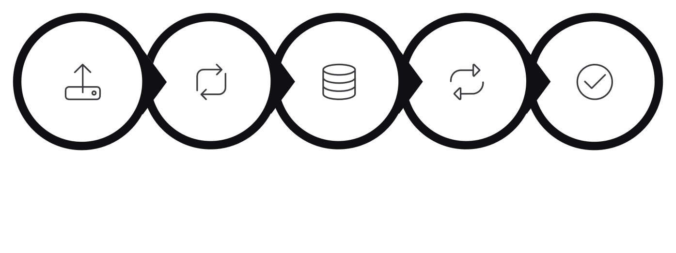
Upload4 Rows
Transform
Insert2/
Update2
RepeatSame File
0Insert/0 Update

